A breath of fresh air
After sitting indoors for a couple of hours, whether listening to a lecture or writing a proposal on the computer, one of the most natural things we want to do is to have a breath of fresh air. Unfortunately such a natural thing is becoming increasingly difficult to find. For people living in mega-cities like Beijing, Shanghai and Guangzhou, a breath of fresh air is almost a luxury.

The main reasons why air pollution is aggravated in cities in developing countries include increasing traffic, growing cities, economic development and industrialization. Smoke for example, is a combination of water vapour, dust and various gases which are largely produced when fuels are burnt (by cars, for example). Smog caused big problems in London in the 19th and early 20th century. From Charles Dickens’ Oliver Twist we know the serious problem of smog in London at that time, and this is why London was named Wu Du, meaning “smoggy capital”. Even today, many Chinese still think London is very smoggy.

Through my own travel experiences in England and my many visits to Beijing in recent years, I'm convinced that Beijing has successfully inherited the name Wu Du from London. In Beijing, in spite of all those claims about “blue skies”, thick smog frequently fouls the air and disrupts hundreds of flights.

In September 2011, I visited London again with my family. We went to see Wesminster, Bridge Big Ben, Tower Bridge, the Globe Theatre, Trafalgar Square, and other places of historical and cultural interest. What impressed us most were the clear blue skies, the green parks (big and small) flowers of all sorts, and seagulls gliding above the River Times, which is the complete opposite of what T.S. Eliot wrote in his poem The Waste Land. In Hyde Park, we even had close encounters with squirrels begging for nuts, pairs of white swans, Canadian geese, Mandarin ducks, and many other wild birds that we could not name. Serenity, beauty and harmony were some of the words that came to mind when strolling through this fabulous park.

Looking at the huge problem of air pollution and serious ecological damage in our country, I strongly feel that we need a breath of fresh air in environmental protection, a breath of fresh air in our legislative bodies in writing laws to control emissions, a breath of fresh air in the scientific research on the damaging effects of and the solutions to air pollution, and a breath of fresh air in our education system, from nursery to postgraduates schools, so that every one of us is aware of the problem and will be prepared to do something about it. If we all take action and make peace with our planet, a breath of fresh air will no longer be a luxury.

教学设计
教学目标
1.
2.
3.
教学流程
- Lead in
Present the picture with heavy pollution and another one with selling fresh air.
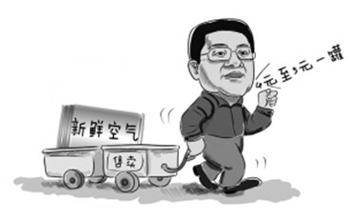
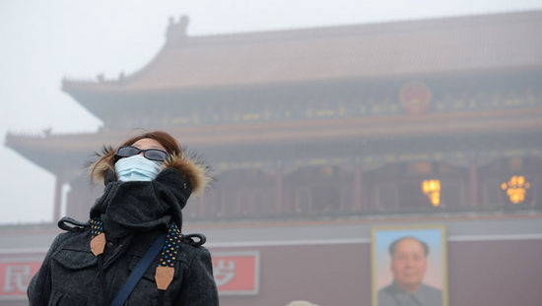

If you lived in heavily air-polluted city, what results it would lead to?
Pneumonia / lung cancer/respiratory disease/ frequent car accidents/ affect plants/ climate change/ global warming
How do you evaluate this piece of News?
It’s ridiculous but it is worth thinking. (We should take action to protect our environment and make piece with the planet.)

- Read paragraph 1 and figure out what would the writer to after sitting indoors for a couple of hours.
To have a breath of fresh air.

- Why does the writer think such a natural thing is almost a luxury? Please go on reading about next paragraph and work out the reasons.
Air pollution is aggravated (become worse and worse) in developing countries include: increasing traffic, growing (become larger) cities, economic development (more factories are built) and industrialization.
- Can you find out any examples to approve that air is seriously polluted?
London has the serious problem of smog. That is why London was named Wudu, which means “smoggy capital”.
I’m convinced that Beijing has successfully inherited the name WuDu from London. Thick smog frequently fouls the air and disrupts hundreds of flights.
- Did the two capital cities change their situation? Read next paragraph and give some evidence.
London changed a lot.
No.
- How can we have a breath of fresh air? Read the last paragraph.

板书设计
A breath of fresh air
is almost a luxury?

increasing traffic

growing cities

economic development

industrialization.

Reasons :

London has the serious problem of smog, and this is why London was named Wu Du, meaning “smoggy capital”.
I'm convinced that Beijing has successfully inherited the name Wu Du from London. In Beijing, thick smog frequently fouls the air and disrupts hundreds of flights.

Examples:


Changes:
the clear blue skies, the green parks (big and small) flowers of all sorts, and seagulls gliding above the River Times. We even had close encounters with squirrels begging for nuts, pairs of white swans, Canadian geese, Mandarin ducks, and many other wild birds that we could not name. Serenity, beauty and harmony were some of the words that came to mind when strolling through this fabulous park.

Solutions:
a breath of fresh air in environmental protection
a breath of fresh air in our legislative bodies in writing laws to control emissions
a breath of fresh air in the scientific research on the damaging effects of and the solutions to air pollution
a breath of fresh air in our education system, from nursery to postgraduates schools, so that every one of us is aware of the problem and will be prepared to do something about it

Results:
If we all take action and make peace with our planet, a breath of fresh air will no longer be a luxury.

